Object Oriented Programming Lab
Spring - 2024 LAB 09

FAST National University of

Computer and Emerging Sciences
Learning Outcomes
In this lab you are expected to learn the following:
- Operator Overloading
Operator Overloading:
C++ allows you to specify more than one definition for an operator in the same scope, which is called operator overloading. Overloaded operators are functions with special names: the keyword "operator" followed by the symbol for the operator being defined.
Syntax for C++ Operator Overloading:
To overload an operator, we use a special operator function. We define the function inside the class or structure whose objects/variables we want the overloaded operator to work with.
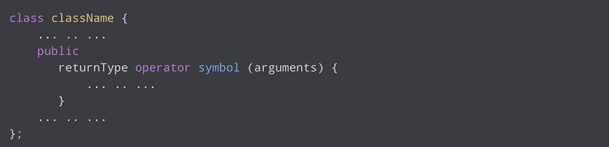
Here,
- returnType is the return type of the function.
- operator is a keyword.
- symbol is the operator we want to overload. Like: +, <, -, ++, etc. ● arguments is the arguments passed to the function.

Example:
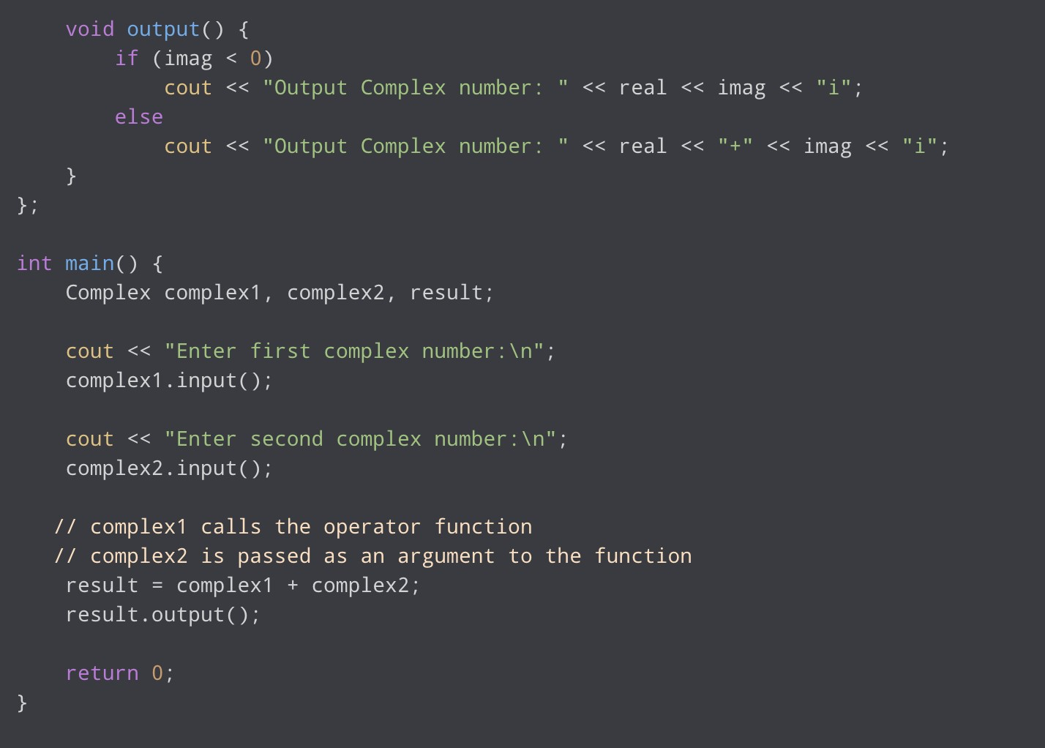

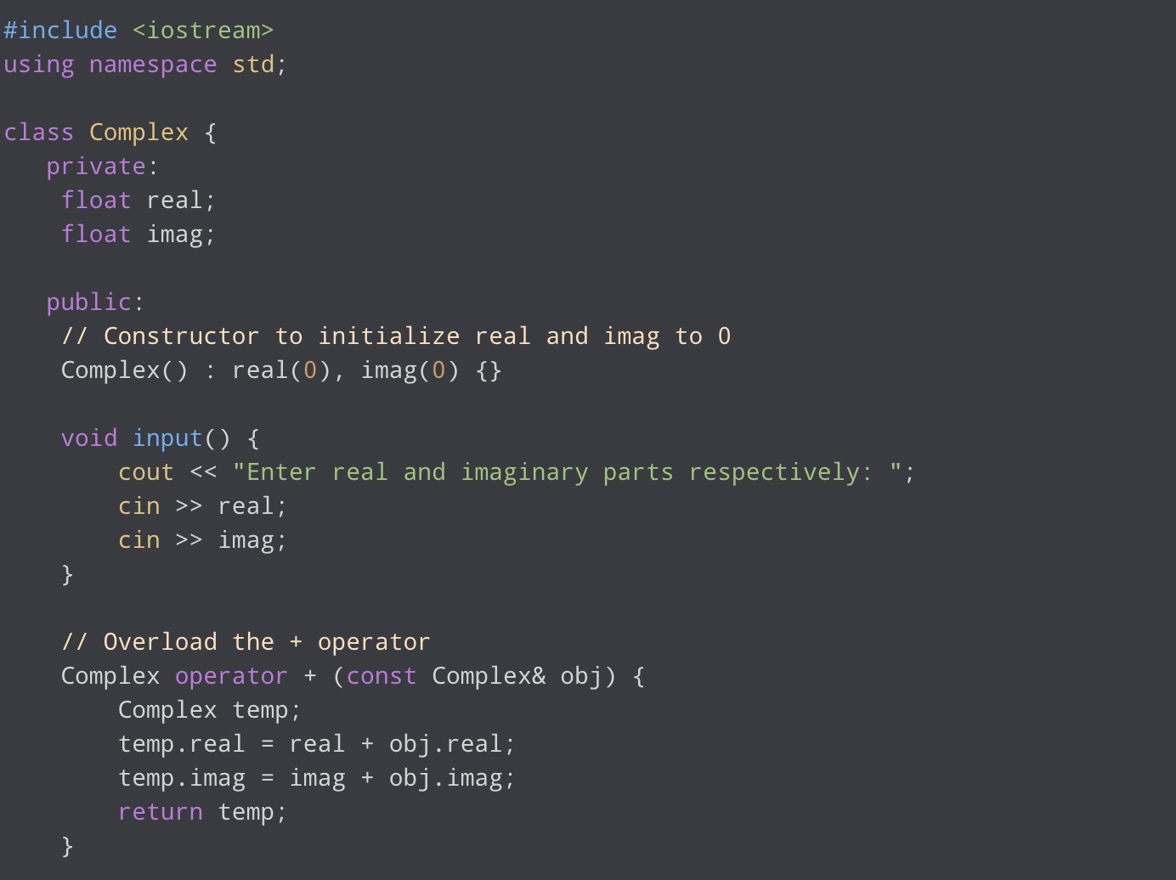

Stream Insertion and Extraction Operator Overloading
In C++, stream insertion operator “<<” is used for output and extraction operator “>>” is used for input.
We must know the following things before we start overloading these operators:
  - cout is an object of ostream class and cin is an object of istream class
  - These operators must be overloaded as global functions. And if we want to allow them to access private data members of the class, we must make them a friend.

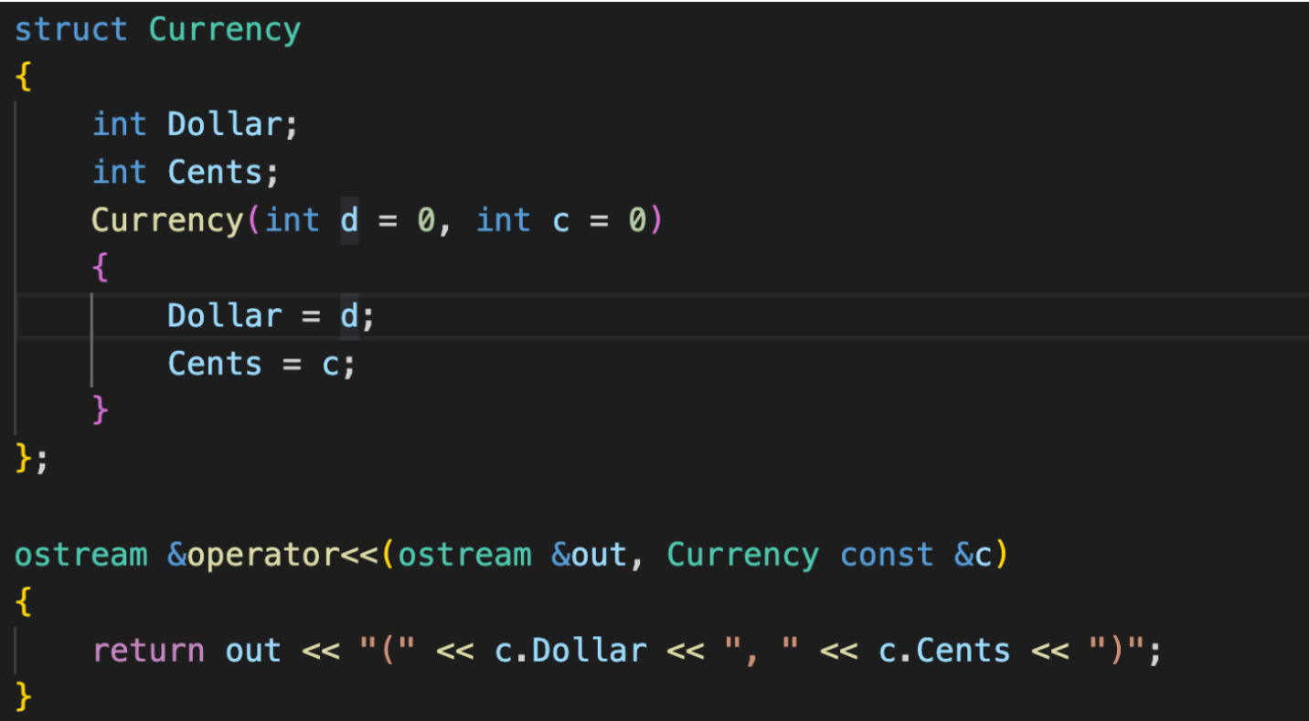
Lab Tasks
Submission Instructions:
- Create a single cpp file containing all the functions of the problems and main function.
- Save the cpp file with the task number
e.g. Q1.cpp
- Now create a new folder with name ROLLNO_SEC_LAB01 e.g. i22XXXX_A_LAB10
- You need to display your roll no and name before the output of each question.
- Move all of your .cpp files (without the main function i.e., comment out the main function) to this newly created directory and compress it into a .zip file.
- Now you have to submit this zipped file on Google Classroom.
- If you don’t follow the above-mentioned submission instruction, you will be marked zero.
- Plagiarism in the Lab Task will result in zero marks in the whole category.
Q1. Define a class Item with the following data members:
- string itemName
- int quantity
- intPrice per unit
1. Write a default constructor 2. Write a parameterized constructor
- Overload the following operators:
  - ++ (prefix) operator will increment the quantity of item by 1
  - - - (prefix) operator will decrement the quantity of item by 1
  - ++ (postfix) operator will increment the quantity of item by 5
  - - - (postfix) operator will decrement the quantity of item by 5
  - += (int n) will increment the quantity of item by n
  - -=(int n) will decrement the quantity of item by n
  - + will add quantity of 2 item in the first item only if the name of items are same
  - ~ will calculate the total price of a single item
  - ! display the item

Q2. Define a class Fraction with the following data members:

- `numerator` (int): Represents the numerator of the fraction.
- `denominator` (int): Represents the denominator of the fraction.

1. Write a default constructor:
- Initializes `numerator` to 0 and `denominator` to 1, representing the fraction 0/1.

2. Write a parameterized constructor:
- Accepts parameters for `numerator` and `denominator` to initialize the respective data members.

3. Overload the following operators:

a. Equality operator (==):
- Compares two fractions for equality based on their numerator and denominator.

b. Greater than operator (>):
- Compares two fractions based on their magnitudes.

c. Less than operator (<):
- Compares two fractions based on their magnitudes.

d. Input stream operator (>>):
- Reads a fraction from the input stream, setting the numerator and denominator accordingly.

e. Output stream operator (<<):
- Writes a fraction to the output stream in the format "numerator/denominator".

f. Addition operator (+):
- Adds two fractions and returns the result as a simplified fraction.

g. Subtraction operator (-):
- Subtracts one fraction from another and returns the result as a simplified fraction.

h. Multiplication operator (*):
- Multiplies two fractions and returns the result as a simplified fraction.

